
PROJECT Synopsis

ON
“LOST AND FOUND PLATFORM”
IN
COMPUTER SCIENCE AND ENGINEERING
SUBMITTED IN PARTIAL FULFILLMENT OF THE DEGREE
OF
BE(CSE)

Submitted By:
Name: Rajendra Chaudhary
University ID No: 2311981617

Department: Computer Science and Engineering

Chitkara University, Himachal Pradesh

1. INTRODUCTION TO PROJECT
1.1 Overview
Almost everyone has misplaced something at some point—or found an item belonging to someone else without knowing how to return it. On a college campus, bags, umbrellas, USB drives, calculators and other belongings are regularly left in lecture halls, cafeterias, laboratories and common areas. Existing responses depend on WhatsApp groups, verbal announcements or notice boards, making information informal, difficult to search and dependent on the right person seeing it at the right time.
The proposed “Lost and Found Platform” addresses this gap through a structured web application in which lost and found items can be reported, searched, matched and returned through a safer process. The system is designed around the MERN stack: MongoDB for data storage, Express.js and Node.js for backend services, and React.js for the frontend. The platform therefore combines organized item records, responsive interaction and controlled communication rather than relying on scattered posts.
1.2 Problem Statement
Current practices suffer from three recurring issues. First, there is no single searchable location for reports, so users must guess which group or notice board to check. Second, contact details may be exchanged before ownership is demonstrated, creating a safety and privacy concern. Third, finders receive little recognition for returning items, reducing motivation to participate. Consequently, items may remain unreturned even when the finder and actual owner are part of the same community.
1.3 Objectives
• Build a single responsive platform where lost and found items can be reported with descriptions, categories, locations and photographs.
• Provide keyword- and category-based searching so that reported items can be located more efficiently.
• Implement the “Double-Handshake” verification process so ownership evidence is checked before personal contact details are revealed.
• Provide a “Next Step Portal” that highlights the most important pending action for a user.
• Provide real-time notifications so users receive updates on claims and other important actions.
1.4 Proposed Solution
The proposed system follows a verification-first approach. A finder posts an item with a description, category and photograph while avoiding unnecessary identifying details. A possible owner raises a claim and submits ownership evidence, such as a unique mark, receipt or private detail. The finder reviews the evidence and approves or rejects the claim. Contact details are revealed only after approval so the two parties can arrange the handover. This two-step process, called the “Double-Handshake”, is the platform’s central safety mechanism.

1.5 Technology Used
The frontend uses React.js with Vite for a responsive and efficient development environment. Tailwind CSS provides consistent styling, Framer Motion supports interface animations, and Lucide React supplies icons. Node.js with Express.js provides REST APIs for user accounts, item listings, claims, notifications and reputation logic. MongoDB Atlas stores application data in a flexible document structure. Cloudinary handles image uploads and hosting. JSON Web Tokens (JWT) are used for authentication and session handling, while bcryptjs hashes passwords before storage so that plain-text passwords are not retained.
1.6 Scope of the Project
The project scope includes registration and login, posting and browsing lost and found items, descriptions and photographs, keyword and category search, the complete Double-Handshake claim and approval flow, Hero Points and badges, the Next Step Portal, and live notifications. The intended deployment scale is a college campus, hostel or residential society where users already interact regularly. City-wide deployment is outside the present scope. Location-radius search and image-similarity matching are considered future enhancements rather than promised features of the current submission.
1.7 Novelty of the Proposed System
The novelty of the platform lies mainly in the combination of features rather than in claiming that each feature is individually new. Double-Handshake brings structured ownership verification into an online lost-and-found process. Hero Points and badges make positive community participation visible. The Next Step Portal reduces the need for users to decide what action to take next by presenting the most relevant pending task. Together, these elements distinguish the proposed system from a basic listing board or classifieds-style application.
1.8 Beneficiaries of the Project
Students and residents are the primary beneficiaries because they gain a structured way to report, search for and recover belongings. College administrations can reduce the time spent handling lost-item complaints at security or administrative offices. Hostels and housing societies can use the same approach for items misplaced in common areas, parking spaces and clubhouses. Over time, the reputation mechanism can also create an informal record of trustworthy community participation.
College administrations can also benefit from the system because it can reduce the time and effort spent handling lost-item complaints at security desks or administrative offices. Instead of depending only on manual records, verbal communication or scattered messages, administrators can have a more organized digital approach for managing lost-and-found information. Hostels and housing societies can similarly use the platform to manage items misplaced in common areas, parking spaces, classrooms, corridors and clubhouses. The platform also benefits finders by providing recognition for responsible participation through Hero Points, reputation and badges. This can encourage users to report found items and contribute to successful returns.
1.9 Expected Outcome
The expected outcome is a working deployed application in which a user can register, post a lost or found item, search and filter listings, submit a claim with supporting evidence and complete a Double-Handshake handover without exposing contact details prematurely. Hero Points and badges should update after successful returns, while the Next Step Portal should reliably direct users toward pending actions. The final project will also include documentation of the database structure, API endpoints and setup procedure so that the system can be reviewed, extended and deployed for a real community.
1.10 Summary
The Lost and Found Platform converts an informal and often unreliable process into a structured digital workflow. Instead of depending on chance, scattered messages and immediate exchange of phone numbers, the proposed system combines searchable listings, ownership verification, community recognition and clear next actions. The following sections review existing approaches, define the development methodology, identify required facilities and provide the study references used for the project.
2. LITERATURE SURVEY
2.1 Traditional and Informal Methods
Traditional campus methods include physical notice boards, verbal announcements and messages circulated through WhatsApp or Telegram groups. They can work when the right person sees the information at the right time, but they provide limited searchability and no durable, centralized record. Once a message moves upward in a group chat, it becomes difficult to retrieve. Claim verification is also informal and is normally left to the person holding the item.
2.2 Social Media and General Classifieds Groups
Dedicated Facebook groups and campus community pages increase reach because a post can be viewed by a large audience quickly. However, these platforms are designed for general discussion rather than lost-and-found management. They typically lack dedicated categories, structured filters and a controlled claim workflow. Contact numbers or other personal information may also be shared openly when someone claims an item, without an ownership check between the possible match and the exchange of personal details.
2.3 Dedicated Lost and Found Mobile Applications
Dedicated lost-and-found applications improve organization by providing item categories, listings and basic search. The reviewed approaches are a genuine improvement over unstructured social-media posts, but they generally follow a post-and-browse model. After a possible match, contact details are often transferred directly to the users so that they can resolve the handover themselves. The reviewed material also identifies limited incentives for users to continue participating after their own item has been recovered or returned. The reviewed approaches are a genuine improvement over informal methods because they reduce dependence on scattered messages and provide a more systematic way to maintain item records.
2.4 Research Gap Identified
The literature survey identifies three recurring gaps in existing lost-and-found systems. The first is the lack of a proper proof-of-ownership check before personal contact information is exchanged, which may create safety and privacy concerns during the recovery process. The second is the lack of meaningful incentives or recognition for finders who make an effort to report and return lost items. The third is that most systems mainly work as static listing platforms, requiring users to search for possible matches and decide their next action without clear guidance. These gaps directly motivate the Double-Handshake, Hero Points, reputation and Next Step Portal features of the proposed platform. The Double-Handshake helps verify ownership before contact details are revealed, while Hero Points and badges encourage responsible participation. The Next Step Portal guides users toward important pending actions, making the overall process more secure, organized and user-friendly.
2.5 Comparative Analysis of Reviewed Approaches
The reviewed approaches show a trade-off between reach, organization and safety. Notice boards and word of mouth have limited reach but can provide some informal verification because people often meet in person. Social-media groups provide wider reach and fast communication, but personal information can be exposed and posts quickly become difficult to find. Dedicated applications improve structure and searchability, yet the reviewed model still tends to move users toward direct contact without a formal ownership check. The proposed platform attempts to retain the useful characteristics of each approach while addressing the major weaknesses.
2.6 Positioning of the Proposed System
The proposed platform keeps structured, searchable listings from the dedicated-application model and combines them with a safer, verification-based handover. The Double-Handshake transfers the caution of face-to-face verification into a controlled online workflow. Hero Points and badges provide visible recognition for helpful behavior, while the Next Step Portal gives users a direct indication of what action should be completed next. The system is therefore positioned not as a replacement for every existing method, but as an integrated approach that combines organization, safety and participation.
2.7 Summary of Literature Survey
The survey indicates that the lost-and-found problem is well understood and that several partial solutions already exist. What remains insufficiently addressed is the combination of searchability, genuine ownership verification and sustained community participation in one workflow. This gap provides the justification for the proposed Lost and Found Platform and explains why Double-Handshake, the reputation system and the Next Step Portal are treated as core design elements rather than optional additions.

3. METHODOLOGY / PLANNING OF WORK
3.1 Requirement Analysis
The project begins by defining concrete user journeys: reporting a lost item, posting a found item, searching listings, raising a claim, verifying ownership and communicating after approval. Non-functional requirements are also identified, especially secure password storage, JWT-based authentication and controlled image handling through Cloudinary.
3.2 System Design
The system design defines MongoDB documents for users, items, claims and notifications and specifies how these records reference one another. In parallel, the Express.js REST API is planned endpoint by endpoint. The React component structure covers the listing feed, item details, claim form, Double-Handshake approval screen, dashboard and Next Step Portal.
3.3 Implementation
Implementation proceeds module by module. Authentication is developed first, followed by item posting and search APIs, claims and the Double-Handshake workflow, notifications, and finally reputation and badge logic. The React frontend is connected to backend services as each functional module becomes available, while Tailwind CSS and Framer Motion are applied after the core functionality is stable.
3.4 Testing
Each module is tested independently and then tested with its connected frontend or backend component. Special attention is given to the Double-Handshake flow to verify that contact details cannot be exposed before a finder approves a valid claim. This testing approach is intended to identify both functional defects and security-related workflow errors.
3.5 Deployment and Documentation
After testing, environment variables are separated for local development and deployment and are maintained outside the codebase through .env files. API documentation, installation instructions and project documentation are updated during development rather than postponed until the final stage.
3.6 Tools and Resources
Visual Studio Code is used for development, Git and GitHub for version control, Postman for API testing, and MongoDB Atlas for the cloud database. The development stack includes React.js, Vite, Tailwind CSS, Framer Motion, Lucide React, Node.js, Express.js, MongoDB, Cloudinary, JWT and bcryptjs.

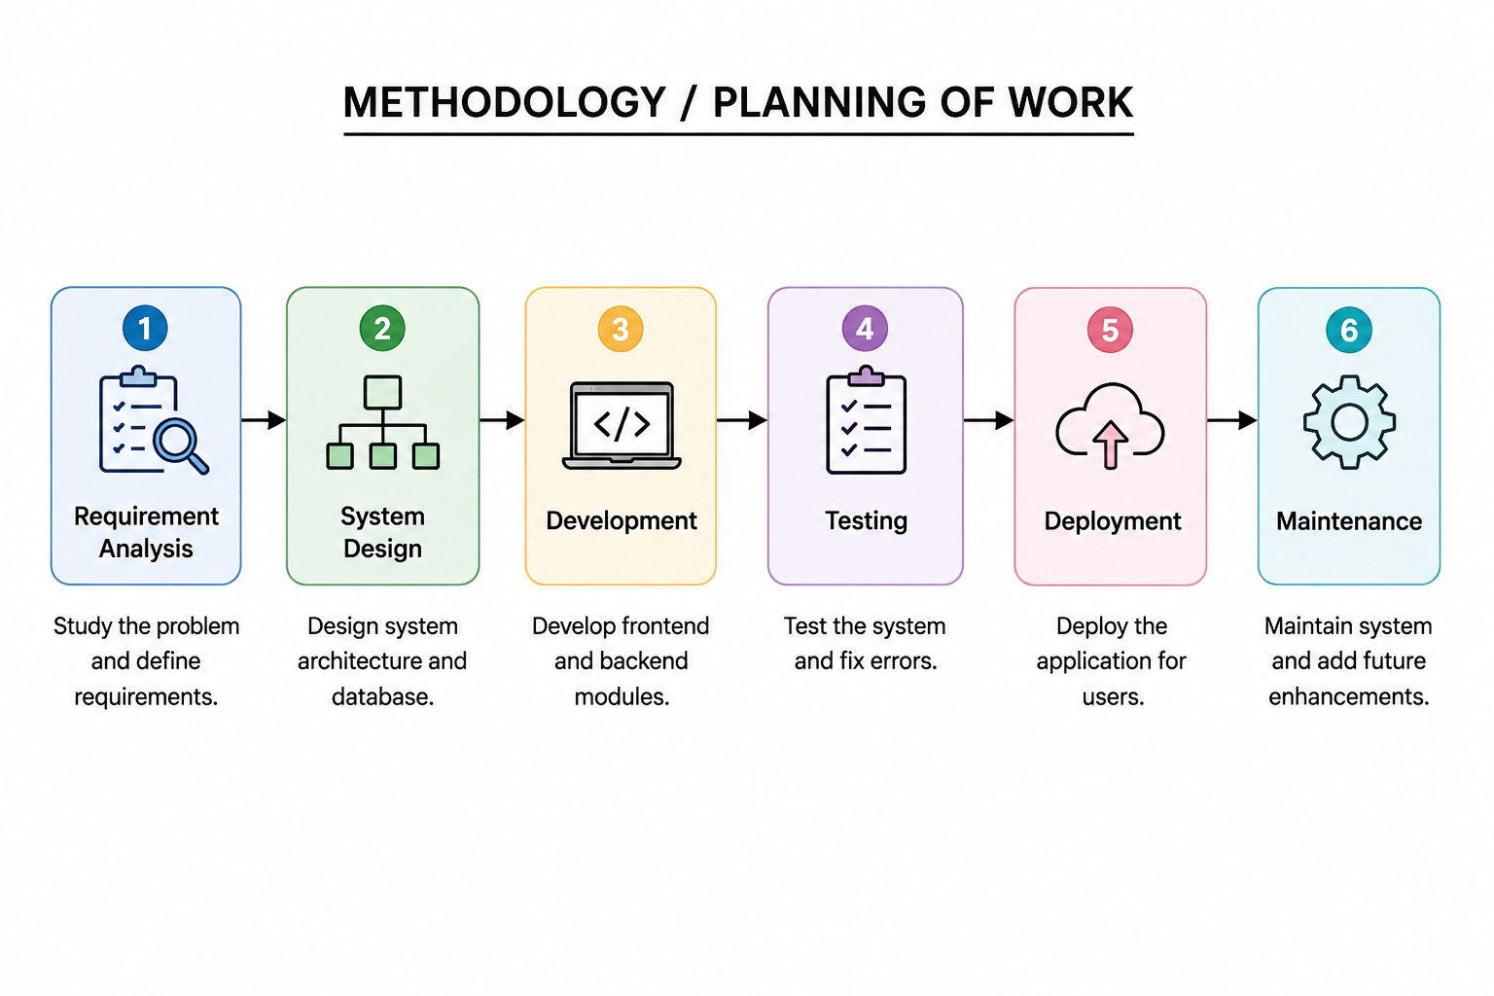
Figure 1: Methodology / Planning of Work

4. FACILITIES REQUIRED FOR PROPOSED WORK
The following hardware and software facilities are required for the design, development, testing and deployment of the Lost and Found Platform.
4.1 Hardware Requirements
Component | Specification
Processor | Intel Core i5 (10th Gen) or equivalent, and above
RAM | 8 GB minimum (16 GB recommended)
Storage | 256 GB SSD or higher
Internet Connection | Stable broadband connection for cloud database and API access
Display | Standard laptop/desktop display for development and testing
4.2 Software Requirements
Component | Specification
Operating System | Windows 10/11, macOS, or Linux
Frontend Framework | React.js with Vite
Backend Runtime & Framework | Node.js with Express.js
Database | MongoDB (Atlas – cloud hosted)
Styling & Animation | Tailwind CSS, Framer Motion, Lucide React
Authentication | JSON Web Tokens (JWT), bcryptjs
Image Hosting | Cloudinary
Code Editor | Visual Studio Code
Version Control | Git and GitHub

5. REFERENCES
[1] React.js Official Documentation – https://react.dev
[2] Node.js Official Documentation – https://nodejs.org/en/docs
[3] Express.js Official Documentation – https://expressjs.com
[4] MongoDB Official Documentation – https://www.mongodb.com/docs
[5] Mongoose ODM Documentation – https://mongoosejs.com/docs
[6] Cloudinary Developer Documentation – https://cloudinary.com/documentation
[7] JSON Web Tokens (JWT) Introduction – https://jwt.io/introduction
[8] Tailwind CSS Official Documentation – https://tailwindcss.com/docs
[9] Vite Official Documentation – https://vitejs.dev
[10] Framer Motion Documentation – https://www.framer.com/motion
[11] United Nations, Sustainable Development Goals – https://sdgs.un.org/goals

